**Hawassa University**



**Institute of Technology**

**Department of Garment engineering**

**Title Production Planning and Control**

**Name**   **Id/no**

1. **Bereket loriso 0497/13**
2. **Robel kefeyalew 2097/13**
3. **Abrham Solomon 0166/13**
4. **Selam Bezabih 1806/12**
5. **Biruk Fituma 0630/13**

**Submitted to – Mr. Tesfaye s**

**Submission date: 24-5-2016**

**Table content**

* **Introduction -------------------------------------------------------------------------------1**
* **Production Planning and Control -------------------------------------------------2**
* **Objectives of Production Planning and Control----------------------------3**
* **Benefits of Production Planning and Control--------------------------------4**
* **Stage of production planning and control ----- -------------------------------5**
* **Elements of production planning and control ------------------------------7**
* **References ----------------------------------------------------------------------------------11**

**. Introduction**

Production Planning & Control (PPC) is a management process that involves the coordination and control of various activities in the production process. It aims to ensure that the right materials, equipment, and labor are available at the right time to meet production targets and customer demands. PPC includes activities such as demand forecasting, production planning, scheduling, inventory control, and quality control. By implementing effective PPC strategies, companies can optimize their production processes, minimize production costs, and enhance overall efficiency and productivity.

1

**Production Planning and Control**

Production planning and control is the process of organizing and allocating all the required business resources to meet production demand promptly and without any disruptions. It outlines the procedure based on which the complete work order preparation in a manufacturing business will proceed The terms "production planning" and "control" relate to two approaches that coordinate key operations effectively throughout the manufacturing process. What to produce, when to produce it, how much to produce, and other factors are all included within this scope. To properly optimize the production flow, production planning must be seen from a long-term perspective.

Production Planning & Control (PPC) can be defined as the process of managing and controlling all aspects of production, from the initial planning stages to the final delivery of products. It involves the coordination of resources, such as raw materials, equipment, and labor, to ensure the smooth flow of production activities and the timely completion of orders. PPC encompasses activities such as demand forecasting, production planning, scheduling, material requirement planning, capacity planning, and quality control. The primary goal of PPC is to optimize production processes, minimize costs, and meet customer demands effectively.

**What Is Production Planning?**

Production planning is the process of determining the most effective and efficient way to manufacture goods or deliver services as per customer expectations. It involves analyzing various factors such as demand forecasts, available resources, production capacity, and delivery schedules to create a comprehensive plan that guides the entire production process. By implementing effective production planning strategies, organizations can achieve improved operational efficiency, reduce lead times, enhance customer satisfaction, and optimize resource allocation. It plays a crucial role in aligning production activities with business objectives, ensuring smooth operations, and facilitating effective decision-making throughout the production process.

2

**What Is Production Control?**

Production control refers to the process of monitoring and managing the execution of production plans to ensure uninterrupted operations on the shop floor. It involves overseeing the actual production activities, tracking progress, and making necessary adjustments to meet production goals and objectives. The primary objective of production control is to maintain the planned production schedule, optimize material and equipment utilization, and ensure that production targets are achieved within the specified timeframes. By effectively managing production control, organizations can achieve improved production flows, minimize wastage and disruptions, and improve on-time delivery performance.

**Objectives of Production Planning and Control**

The following are the main objectives of production planning and control:

Optimum utilization of resources, such as machinery, raw material, and labor to fulfill production demands.

* To maintain optimum stock levels.
* To make sure capacity utilization matches anticipated demand.
* Ensure that the appropriate amount and quality of raw materials, tools, manpower, and equipment are available during production.
* To reduce setup and idle time on machines.
* Coordinate with other production-related departments, such as sales and order management services to achieve uninterrupted production flow.
* To facilitate cost control and cost reduction.
* To ensure a profitable and reliable production process.
* To reduce labor turnover and improve client satisfactio**n.**

3

**Importance of Production Planning and Control**

A production planning and control system works hard to ensure that the business delivers orders as per quality standards and customer expectations. Here are a few reasons why it's important to have efficient production planning and control in place:

Managers can use production planning and control to determine how much stock they'll need by planning each step of the production process.

Production planning facilitates decision-making by understanding current trends and demands.

It helps in employing the right resources at the right places without exceeding budgets.

Production planning and control are also essential for resource management as they can determine the near-exact requirement of direct materials, semi-finished goods, and finished goods throughout diverse production cycles.

It's also important for better coordination across various business functions.

**Benefits of Production Planning and Control**

Some of the advantages of production planning and control are:

* **Uninterrupted Production:**

Expert production planning and control results in uninterrupted production thanks to the elimination of related holdbacks, such as shortage of materials, tools, and poor machine maintenance.

* **Cost Control and Higher Productivity**

It leads to cost control, higher productivity, and hence, maximization of profits due to optimum use of available resources. Businesses can also achieve a reduction in costs associated with storage and material handling.

**4**

* **Guaranteed Consumer Satisfaction**

Guaranteed consumer satisfaction and improved client relationships are

other benefits of production planning and control, accomplished due to on-time deliveries.

* **Minimized Resource Wastage**

Effective production planning and control practices contribute to minimizing idle time across activities, resulting in efficient resource utilization and reduced wastage.

* **Increased Manufacturing Capacity**

Businesses can incorporate production planning and control to ensure that labor and machinery are also used optimally. Streamlined production processes lead to improved overall efficiency and effectiveness.

* **Better Material Procurement**

Businesses can enable better material management to indicate when materials should be bought for production. This promotes financial savings and strengthens connections with suppliers.

* **Enhanced Decision-Making**

Efficient production planning and control provide access to accurate data and insights for informed decision-making in production planning and control.

* **Continuous Process Improvement**

Regular monitoring and evaluation of production processes with planning and control, allow for continuous improvement and optimization across the business.

Production planning and control (PPC) is a crucial process in manufacturing, ensuring smooth operations, resource optimization, and timely delivery of products. It involves **two key stages**:

**5**

**1. Production Planning**

**Demand Forecasting:** This stage involves predicting future demand for products based on historical data, market trends, and marketing plans. It helps determine what, how much, and when to produce.

Forecasting in production planning and control is the first and most important step. Analyze historical data, market trends, and customer demand patterns to forecast future demand for products. This serves as a basis for production planning.

**Master Production Scheduling (MPS)**: Using the demand forecast, the MPS outlines the overall production plan, specifying what products to be produced in what quantities and by when. It considers factors like available resources, lead times, and capacity constraints.

The creation of a production plan is assisted by key information from numerous sources, including data from sales. This consists of data such as order quantity, promised delivery date, and data from the engineering department, such as any relevant technical specifications.

**Material Requirements Planning (MRP)**: Based on the MPS, MRP calculates the exact amount and timing of materials needed for each

production stage. It ensures timely procurement and avoids stockouts or overstocking.

MRP helps you calculate the materials needed for production based on

master planning. Consider factors such as lead times, inventory levels, and production constraints to generate material requirements planning and procurement recommendations.

**2. Production Control**

**Shop Floor Control (SFC):** This stage monitors and manages the actual

6

production process on the shop floor. It involves tasks like order sequencing, job scheduling, work in progress (WIP) tracking, and performance monitoring.

**Inventory Control**: This ensures optimal inventory levels of raw materials, finished goods, and WIP to avoid stockouts and minimize holding costs.

**Quality Control:** This involves inspecting products at various stages of production to ensure they meet quality standards. It may involve corrective actions and adjustments to prevent defective products.

**Performance Measurement:** This involves tracking key performance indicators (KPIs) like production output, lead times, and resource utilization to identify areas for improvement and evaluate the effectiveness of the PPC system

**the main elements of production planning and control (PPC), along with some examples:**

1. **Demand forecasting:** This involves predicting future customer demand for a product or service. This can be done using historical sales data,

market research, and other factors. For example, a toy manufacturer might use sales data from the previous holiday season to forecast demand for the upcoming season.

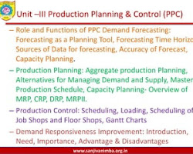

2. **Master production scheduling (MPS):** This is the heart of PPC, and it translates the demand forecast into a specific production plan. The MPS specifies what products will be produced, in what quantities, and when. For

7

example, the MPS for the toy manufacturer might specify that 10,000 dolls need to be produced by November 1st.

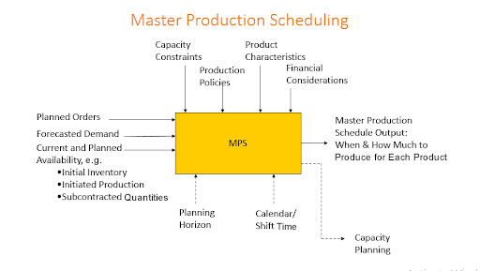

3. **Material requirements planning (MRP):** This ensures that all the materials needed for production are available in the right quantities, at the right time, and at the right place. MRP takes into account the MPS, inventory levels, lead times, and other factors. For example, the MRP system for the toy manufacturer might generate a purchase order for 10,000 doll bodies, 20,000 doll heads, and 40,000 doll outfits.

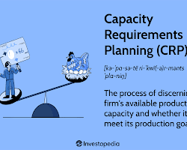

**4. Capacity planning:** This involves ensuring that the production process has the capacity to meet the demands of the MPS. This includes considering factors such as available equipment, labor, and space. For

8

example, the capacity plan for the toy manufacturer might include adding an extra production line to meet the demand for dolls**.**

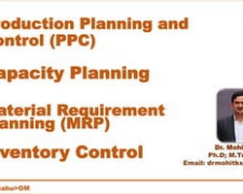

**5. Shop floor control: T**his involves monitoring and controlling the production process on a day-to-day basis. This includes activities such as scheduling jobs, tracking progress, and identifying and resolving problems. For example, the shop floor control system for the toy manufacturer might track the progress of each doll on the production line and identify any bottlenecks that need to be addressed

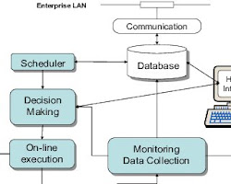

**6. Quality control: T**his involves ensuring that the products meet the required quality standards. This includes activities such as inspecting products at various stages of the production process. For example, the

9

quality control system for the toy manufacturer might inspect each doll to ensure that it meets safety standards

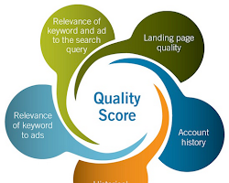

**10**

**References**

**letstranzact.com**

**fr.slideshare.net**

**optiproerp.com**

**investopedia.com**

11